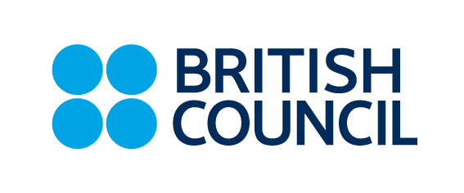

# TEACHING CENTRE REfund request

# ENGLISH COURSES

#### Personal details

|  |  |
| --- | --- |
| Student name: | |
| Student ID: | Class name/code: |
| Tel. number: | Email: |
| IBAN: | Account holder: |

#### student statement

Please give the **reason** for your refund request ( ✓ tick one box )

|  |  |
| --- | --- |
| Health/medical | Work/study commitments |
| Other (please specify) | |

Student/Parent signature .......................................................... Date:

**Please send the completed and signed form by email to:** [**learnenglish@britishcouncil.bg**](mailto:learnenglish@britishcouncil.bg)

#### registration and course conditions

* The maximum number of students in a class is 14. Places are available on a first come, first served basis so we cannot guarantee a place on a course.
* We reserve the right to close a class before the start date if fewer than six students are registered. If this happens, we will offer you a place in another class at the same level or give you a full refund.

#### refunds and credit policy

* If you make a refund request before the advertised start date of your course, we will give you a full refund or credit.
* If you ask for a refund in the first half of your course (or in the first two days of an intensive Summer course), we will give you a part refund or part credit. This means we will keep BGN 80 as an administration charge plus the fee for any past lessons.
* We do not give refunds or credits in the second half of a course.

### For office use only:

Request checked: ..................................... Date: ……………

APPROVED REJECTED

(Teaching Operations Manager) ..................................... Date: ……………